SESSION 8
Probability Distributions (Discrete)
Bernoulli, Binomial and Poisson: Assignment Notes with Worked Demo

1. Bernoulli Distribution

1.1 Random variables and discrete distributions
A random variable assigns a number to the outcome of a random process. It is discrete when it can take only countable values such as 0, 1, 2, 3 and so on (number of clicks, number of defects, number of tickets). A discrete probability distribution lists every possible value together with its probability.
- Probability mass function (PMF): P(X = x) gives the probability of each exact value x.
- Rules: every probability lies between 0 and 1, and all probabilities add up to 1.
- Cumulative probability: P(X ≤ x) is the sum of the PMF up to x.

1.2 The Bernoulli distribution
A Bernoulli trial is a single experiment with exactly two outcomes: success (X = 1) and failure (X = 0). The probability of success is p and the probability of failure is 1 − p.
P(X = x) = p^x × (1 − p)^(1 − x), x = 0 or 1
- Mean: E(X) = p
- Variance: Var(X) = p × (1 − p)
- Parameter: p, the probability of success.

1.3 Example
Question: A customer clicks on a marketing email with probability 0.30. Describe the Bernoulli distribution of one customer.
Solution: Let X = 1 if the customer clicks and X = 0 otherwise.
- P(X = 1): 0.30
- P(X = 0): 1 − 0.30 = 0.70
- Mean: E(X) = 0.30
- Variance: 0.30 × 0.70 = 0.21

2. Binomial Distribution

2.1 Definition
The binomial distribution counts the number of successes in n independent Bernoulli trials, each with the same success probability p. It is the sum of n Bernoulli variables.
P(X = k) = C(n, k) × p^k × (1 − p)^(n − k)
Here C(n, k) = n! / (k! × (n − k)!) is the number of ways to choose which k of the n trials are successes.

2.2 Conditions and properties
- Fixed trials: the number of trials n is decided in advance.
- Two outcomes: each trial is a success or a failure.
- Independence: the result of one trial does not affect another.
- Constant probability: p is the same on every trial.
- Mean and variance: E(X) = n × p and Var(X) = n × p × (1 − p).
- Special case: a binomial with n = 1 is a Bernoulli distribution.

2.3 Example
Question: A company sends 10 emails and each is clicked with probability 0.20. Find the probability that exactly 3 are clicked, and the probability that at most 2 are clicked.
Solution: Here n = 10 and p = 0.20.
- Exactly 3: P(X = 3) = C(10, 3) × 0.2³ × 0.8⁷ = 120 × 0.008 × 0.2097 = 0.2013
- At most 2: P(X ≤ 2) = P(0) + P(1) + P(2) = 0.1074 + 0.2684 + 0.3020 = 0.6778
- Mean: E(X) = 10 × 0.20 = 2 clicks.
- Variance: Var(X) = 10 × 0.20 × 0.80 = 1.6.

3. Poisson Distribution

3.1 Definition
The Poisson distribution counts how many times an event occurs in a fixed interval of time, area or volume, when events happen independently at a constant average rate. Unlike the binomial, there is no fixed number of trials and the count has no upper limit.
P(X = k) = e^(−λ) × λ^k / k!, k = 0, 1, 2, ...
- λ (lambda): the average number of events per interval (λ > 0), and e ≈ 2.71828.
- Mean and variance: E(X) = λ and Var(X) = λ. Both are equal, which is a useful check on real data.

3.2 Conditions
- Counts: events are counted over a fixed interval (per day, per hour, per page).
- Independence: one event does not make another more or less likely.
- Constant rate: the average rate λ is stable over the interval.
- One at a time: events do not occur at exactly the same instant.

3.3 Example
Question: A help desk receives 4 tickets per day on average. Find the probability of exactly 2 tickets on a given day, and of at least one ticket.
Solution: Here λ = 4.
- Exactly 2: P(X = 2) = e⁻⁴ × 4² / 2! = 0.0183 × 16 / 2 = 0.1465
- Zero tickets: P(X = 0) = e⁻⁴ = 0.0183
- At least one: P(X ≥ 1) = 1 − 0.0183 = 0.9817

3.4 Poisson as an approximation to the binomial
When n is large and p is small, a binomial distribution is very close to a Poisson distribution with λ = n × p. For example, with n = 1000 and p = 0.004 (so λ = 4), the binomial gives P(X = 2) = 0.1464 and the Poisson gives 0.1465.

3.5 Comparing the three distributions
Distribution | What it models | Parameters | Mean | Variance
Bernoulli | One trial: success or failure | p | p | p(1 − p)
Binomial | Successes in n fixed trials | n, p | n × p | n × p × (1 − p)
Poisson | Events in a fixed interval | λ | λ | λ

4. Use-cases in Analytics
Distribution | Analytics use-case | Question it answers
Bernoulli | Click or no click, purchase or no purchase, churn or stay, default or repay | What is the probability that one customer converts?
Binomial | Conversions out of n visitors, defective items in a batch, correct answers in a quiz, A/B test results | How many of 100 visitors will convert? What is the chance of 5 or more defects in a batch of 50?
Poisson | Support tickets per day, website visits per minute, calls per hour, system failures per month, defects per metre | How likely is a day with more than 10 tickets? How many agents are needed?

- Forecasting and planning: staffing, inventory and server capacity depend on how many events to expect.
- Risk and quality control: tail probabilities show how rare an extreme day or a high defect count really is.
- Foundation for models: logistic regression uses a Bernoulli outcome and Poisson regression uses count data.

5. Working with Distributions in Python
The scipy.stats module gives the same set of functions for every distribution:
- pmf(k, ...): probability of exactly k, that is P(X = k).
- cdf(k, ...): cumulative probability P(X ≤ k).
- sf(k, ...): survival function P(X > k), which equals 1 − cdf(k).
- ppf(q, ...): the smallest k whose cumulative probability is at least q (percentile).
- rvs(size=n, ...): random samples drawn from the distribution.
The distributions are called bernoulli(p), binom(n, p) and poisson(mu), where mu is λ.

6. Demo: Number of Daily Support Tickets

6.1 Problem statement
A support team recorded the number of tickets received on each of 30 days. Check whether the daily count can be modelled by a Poisson distribution, estimate λ, and use the model to find useful probabilities for capacity planning. The figures are illustrative for this demo.

6.2 Data
Tickets per day (30 days): 8, 4, 8, 2, 6, 6, 8, 7, 4, 5, 6, 6, 7, 9, 4, 7, 10, 1, 6, 3, 8, 8, 5, 6, 4, 7, 8, 7, 1, 3

6.3 Python code
import numpy as np
import matplotlib.pyplot as plt
from scipy.stats import poisson

# Daily support tickets for 30 days - illustrative
tickets = np.array([8, 4, 8, 2, 6, 6, 8, 7, 4, 5, 6, 6, 7, 9, 4,
7, 10, 1, 6, 3, 8, 8, 5, 6, 4, 7, 8, 7, 1, 3])

lam = tickets.mean() # estimate of lambda
print("Mean (lambda):", round(lam, 2))
print("Variance:", round(tickets.var(ddof=1), 2))

print("P(X = 6):", round(poisson.pmf(6, lam), 4))
print("P(X <= 3):", round(poisson.cdf(3, lam), 4))
print("P(X >= 10):", round(poisson.sf(9, lam), 4))
print("95th percentile:", int(poisson.ppf(0.95, lam)))

# Observed relative frequency vs Poisson probability
k = np.arange(0, 14)
observed = np.array([(tickets == i).mean() for i in k])
expected = poisson.pmf(k, lam)

plt.bar(k - 0.2, observed, width=0.4, label="Observed (30 days)")
plt.bar(k + 0.2, expected, width=0.4, color="orange", label="Poisson model")
plt.xlabel("Tickets per day")
plt.ylabel("Probability")
plt.title("Daily Support Tickets: Observed vs Poisson")
plt.legend()
plt.show()

6.4 Output
Mean (lambda): 5.8
Variance: 5.34
P(X = 6): 0.1601
P(X <= 3): 0.17
P(X >= 10): 0.0708
95th percentile: 10

6.5 Observed vs Poisson
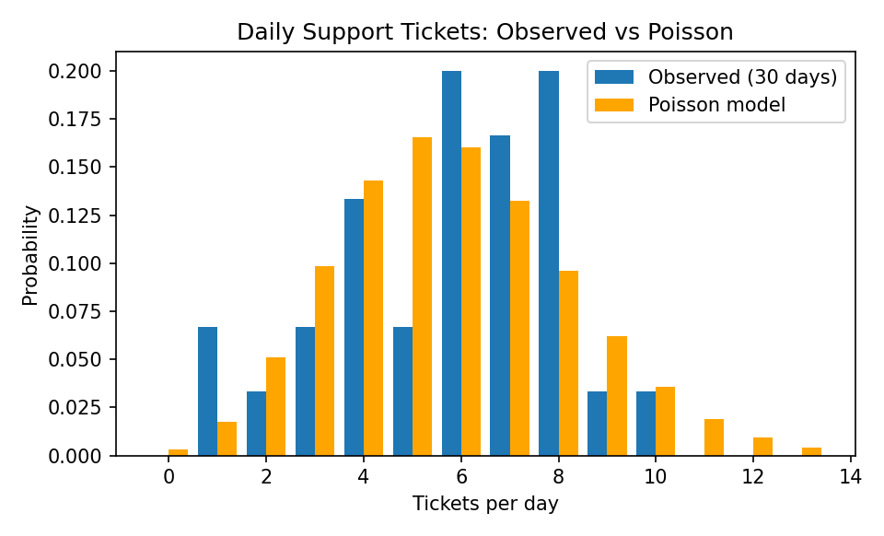
Figure 1: Observed daily ticket frequencies compared with the Poisson model

6.6 Fitted model
X ~ Poisson(λ = 5.8), P(X = k) = e^(−5.8) × 5.8^k / k!

6.7 Interpretation
- Poisson check: the mean (5.80) and the variance (5.34) are close to each other, as a Poisson distribution requires. The bars in Figure 1 also follow the model closely.
- Typical day: the team receives about 5.8 tickets per day on average. The most likely counts are 5 and 6 (probabilities 0.166 and 0.160).
- Quiet days: P(X ≤ 3) = 0.17, so about 17% of days have 3 or fewer tickets. In the data, 5 of 30 days (16.7%) did.
- Busy days: P(X ≥ 10) = 0.0708, so roughly 1 day in 14 brings 10 or more tickets. In the data, 1 of 30 days did.
- Capacity planning: the 95th percentile is 10, so staffing to handle 10 tickets per day covers about 95% of days (P(X ≤ 10) = 0.965).
- Caution: Poisson assumes a constant rate and independent tickets. Weekday and weekend differences, product launches or a single outage that triggers many tickets break these assumptions, and then the variance becomes much larger than the mean.

Key Takeaways
- Bernoulli: one trial with two outcomes. Mean p, variance p(1 − p).
- Binomial: number of successes in n independent trials with probability p. Mean np, variance np(1 − p).
- Poisson: number of events in a fixed interval at average rate λ. Mean and variance both equal λ.
- Relationships: binomial with n = 1 is Bernoulli, and binomial with large n and small p is approximately Poisson with λ = np.
- Analytics: use Bernoulli and binomial for conversion-type yes/no outcomes, and Poisson for counts per interval such as daily tickets.
- Python: scipy.stats gives pmf(), cdf(), sf(), ppf() and rvs() for every distribution.

